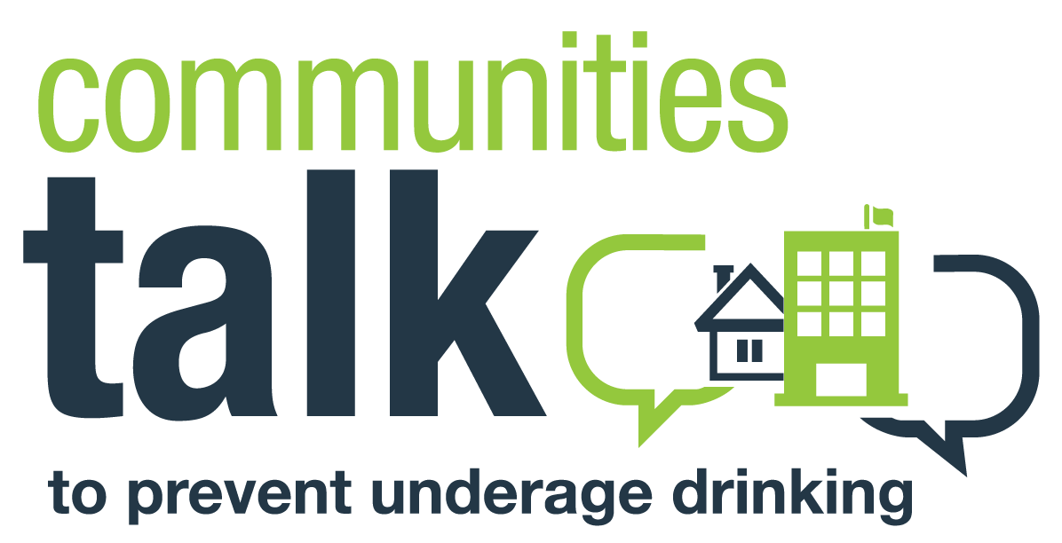

Preventing Underage and Problem Drinking

[Location/Virtual Meeting link]
[If virtual, include phone number for participants to call in]
[Date]
[Time]
Welcome and Introductions of Speakers (5 minutes)
Acknowledgment of Contributing Community Organizations
Opening Presentation (10 minutes)
[Who] Host Organization Spokesperson
[Potential topic] How Alcohol Affects Our Community
Video: SAMHSA’s The Sound of Your Voice
Panel Discussion (35 minutes)
[Who] School Administrator
[Potential topic] What Students Should Know About the Long-Term Effects of Alcohol
[Who] Student Leader
[Potential topic] The Risks of Underage and High-Risk Drinking
[Who] Law Enforcement Officer
[Potential topic] Crash Course in Alcohol-Related Consequences
[Who] Students Against Destructive Decisions (SADD) Representative
[Potential topic] How Avoiding Alcohol Opens Doors
Panel Wrap-Up (5 minutes)
[Who] Host Organization Spokesperson and Student Leader
[Potential topic] Call to Action: Safe and Sober Weekends
Question-and-Answer Session (20 minutes)
[Who] Host Organization Spokesperson and All Panel Members
Summary of Proposed Next Steps/Closing (5 minutes)
[Who] Host Organization Spokesperson
[Organizer’s Note: The above text shows a sample agenda that an organization might create when partnering with a local college or university to host a Communities Talk in-person or virtual activity. In this scenario:
- Students and their parents are the audience.
- The prevalence of underage drinking and the consequences of misusing alcohol are the topics.
- The call to action is to provide alternative alcohol-free graduation celebrations.
- The activity includes a question-and-answer session for attendees to brainstorm next steps.
Customize your activity to meet the needs of your community. Use this sample agenda as a guide.]

