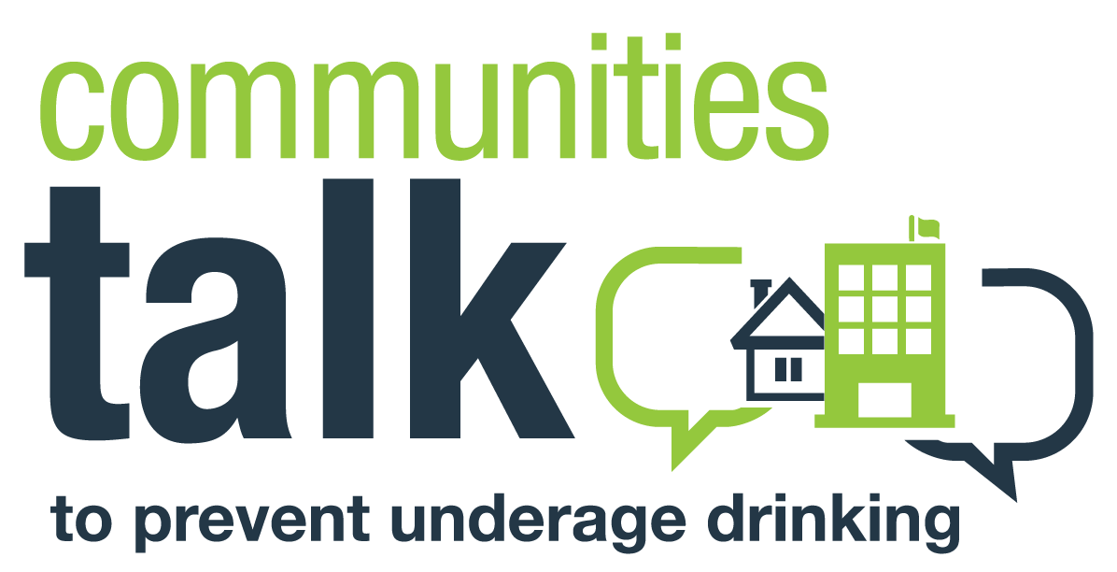
PITCH EMAIL TEMPLATE

[Use an attention-grabbing subject line, e.g., Protecting the Future of Youth in [Name of City, Town, County, or Reservation]; Underage Drinking Prevention Event/Activity Set for [Date] Important First Step

Last year, [add a compelling data point on the toll of underage drinking in your community; review the state data in the state resources section of the Communities Talk website.]

Our community does not accept this, and we are taking meaningful steps to address underage drinking locally.

Please join us on [date and time of event or activity] at [location] as [community] comes together for an activity as part of the Substance Abuse and Mental Health Services Administration’s Communities Talk to Prevent Underage Drinking to discuss ways to improve our community’s health and future. [Add speaker notes, e.g., the Chief of Police will discuss current enforcement efforts and what more needs to be done to help prevent underage drinking consequences, teens from our high school will present the results of a survey they conducted on where teens access alcohol.]

I will be in touch [1 week before the event] to confirm your interest in joining this activity. Please contact me at [phone number] or [email address] if I can answer any questions in the meantime.

