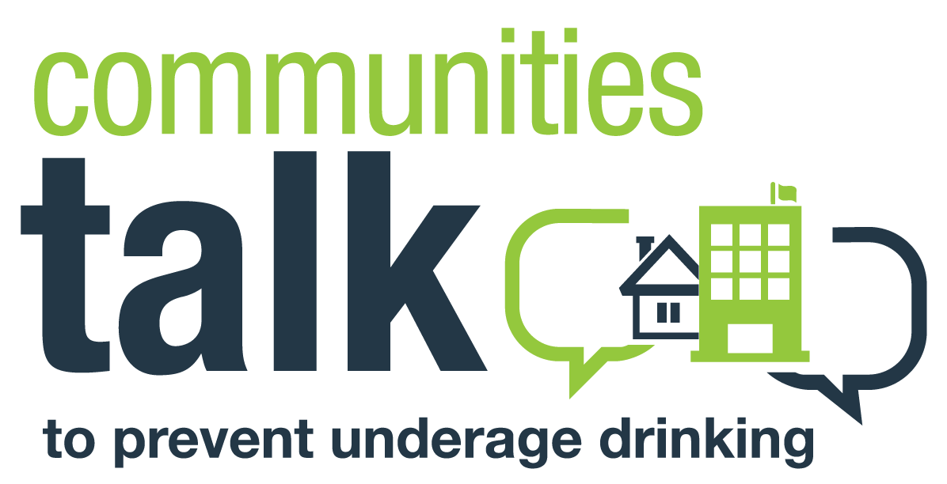
MEDIA ADVISORY

Date:
Contact:
[Name of press contact]
[Contact phone number and email address]

[Strong, attention-grabbing headline]
[Organization Name] Commits/Re-Commits to Take Meaningful Steps to Prevent Underage Drinking in [City, Town, County, or Reservation]

[Add a subhead with more details]
Communities Talk to Prevent Underage Drinking Works to Improve the Future for Young Adults in [City, Town, County, or Reservation] with [Virtual] Activity on [Date] at [Time]

WHAT: [Organization/community name], with support from the Substance Abuse and Mental Health Services Administration (SAMHSA), will hold [name of activity] as part of SAMHSA’s Communities Talk to Prevent Underage Drinking initiative. The [virtual] activity will [purpose: raise awareness about the negative impact of underage drinking, introduce new laws that prevent those under 21 from obtaining alcohol, mobilize the community to take action, etc.]. [Add a few details to support your event or activity.]

WHEN: [Date and time of event or activity]

WHERE: [Registration link or public location for activity]

WHO: [Speakers’ names and organizations]

WHY: Last year in [City, Town, County, or Reservation], alcohol impacted our young adults—and our community at large—in the following ways:
- [Insert data paints about any alcohol-related negative outcomes in your state, such as assaults, vehicle crashes, etc. Review the state data in the state resources section of the Communities Talk website for specific information.]

To schedule an interview with [spokesperson(s)], please contact [press contact] at [email or phone].
When communities talk, prevention is possible. For more information, visit: http://www.stopalcoholabuse.gov/communitiestalk. Join the online conversation using #CommunitiesTalk.

–30–

