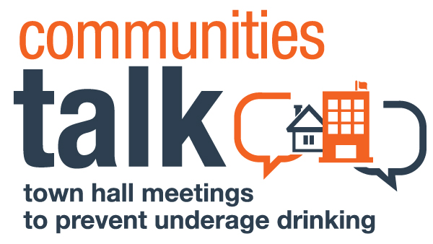

MEDIA THANK YOU NOTE TEMPLATE

Dear [contact’s name—use first name if appropriate]:

[Paragraph 1: Thank the media representative for participating. You can also remind the reporter about something that was said during the event that ties into the importance of ensuring media attention on this issue.]

Thank you for participating in [event name] on [date, including the day of the week], at [time], at [location]. “[Notable speaker quote],” said [speaker’s name].

Having you be part of this event is important to ensure that underage drinking prevention remains in the public eye. This is incredibly important to encouraging communities like ours to talk about underage drinking, and take action to curb its consequences by [e.g., decreasing youth access to alcohol in the community, increasing compliance checks, etc.], which we discussed.

[Paragraph 2: Closes the note and offers an event photo if you have one, to encourage media coverage. End your note with a promise that you will be in touch as future prevention/intervention activities are planned.]

I have enclosed one or more event photos for your use. Please contact me at [phone number]or [email] if I can answer any additional questions.

Sincerely,
[Your name]
[Title]
[Organization]

