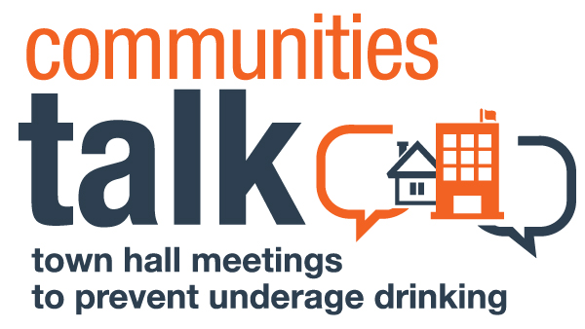
PITCH EMAIL TEMPLATE

[Use an attention-grabbing subject line, e.g., Underage Drinking Prevention Event on [Date] Focuses on Improving the Future of Youth in [Name of City, Town, County or Reservation]

Last year, [#] young people under 21 died from alcohol-related traffic crashes in our state. [Review the state data in the state resources section of the Town Hall Meetings website.]

Please join us on [date and time of event] at [location] as [community] comes together for an event as part of Communities Talk: Town Hall Meetings to Prevent Underage Drinking to discuss ways to improve the future of our community. [Add speaker notes, e.g., the Chief of Police, will discuss current enforcement efforts and what more needs to be done to help prevent underage drinking consequences. Teens from Our Town High School will present the results of a survey they conducted on how many teens use alcohol and where they access it.]

I will be in touch [1 week before the event] to confirm your availability. Please contact me at [phone number] or [email address] if I can answer any questions in the meantime.

