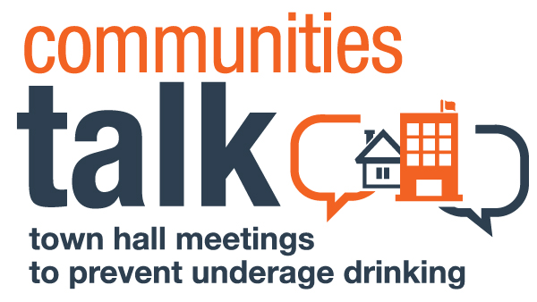
MEDIA ADVISORY
Date:
Contact:
[Name of spokesperson]
[Contact phone number and email address]

[Strong, attention-grabbing headline]
[Organization Name] Calls on [City, Town, County or Reservation] to Take Action on Underage Drinking

[Add a subhead with more details]
Communities Talk: Town Hall Meetings to Prevent Underage Drinking Works to Improve the Future for Young Adults with Event on [Date] at [Time] in [Location]

WHAT: [Organization/community name], in collaboration with the Substance Abuse and Mental Health Services Administration (SAMHSA), will hold [name of event] as part of Communities Talk: Town Hall Meetings to Prevent Underage Drinking. The event will [purpose: raise awareness about the negative impact of underage drinking, introduce new laws that prevent those under 21 from obtaining alcohol, mobilize the community to take action, etc.]. [Add a few details to support your event.]

WHEN: [Date and time of event]

WHERE: [Name of location and full address]

WHO: [Speaker names and organizations they are representing]

WHY: Last year in [City, Town, County, or Reservation], alcohol impacted our young adults—and our community at large—in the following ways:

- [Insert statistic about assaults, if available].
- [Insert statistic about vehicle crashes, if available.]
- [Insert statistic about any other alcohol-related negative outcome. [Review the state data in the state resources section of the Town Hall Meetings website for specific information.]

When communities talk, prevention is possible. For more information, visit: http://www.stopalcoholabuse.gov/townhallmeetings. Join the online conversation, #CommunitiesTalk.
###

