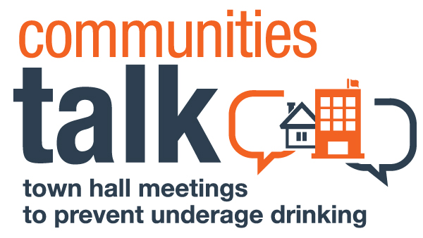

Preventing Underage and High-Risk Drinking

[Location e.g. Community Center Name]
[Date]
[Time]
Welcome and Introductions of Guest Speakers (5 minutes)
Acknowledgment of Contributing Community Organizations
Opening Presentation (10 minutes):
Host Organization Spokesperson
How Alcohol Affects Our Community
Video: The Sound of Your Voice
Panel Discussion (35 minutes)
School Administrator
What Students Should Know About the Long-Term Effects of Alcohol
Campus Leader (Student)
The Risks of Underage and High-Risk Drinking
Law Enforcement Officer
Crash Course in Alcohol-Related Consequences
Students Against Destructive Decisions (SADD) Representative
How Avoiding Alcohol Opens Doors
Panel Wrap-Up (5 minutes)
Host Organization Spokesperson and Student Leader
Call to Action: Safe and Sober Weekends
Question-and-Answer Session (20 minutes)
Summary of Proposed Next Steps/Closing (5 minutes)

[Organizer’s Note: The above text shows a sample agenda that an organization might create when partnering with a local college to host a Town Hall Meeting. In this scenario:
- Students and their parents are the audience.
- The consequences of misusing alcohol is the topic.
- The call to action is to provide alcohol-free graduation celebrations.
- The event includes a question-and-answer session for attendees to brainstorm next steps.
Customize your event to meet the needs of your community. Use this sample agenda as a guide.]

